PRIMARY KEYWORDS

- Employment attorney Saratoga CA
- Employment law attorneys in Saratoga
- California employment law attorneys
- Employment lawyer Silicon Valley

LOCATION-BASED KEYWORDS
- Saratoga, California
- Silicon Valley
- Santa Clara County
- Bay Area

PRACTICE-SPECIFIC KEYWORDS
- Wrongful termination attorney Santa Clara County
- Workplace discrimination
- Sexual harassment
- Retaliation claim defense
- PAGA defense California
- PAGA notice response
- Wage and hour disputes / violations
- Employment discrimination lawyer Saratoga
- Severance agreements California
- Employment contracts
- California Labor Commissioner
- FEHA (Fair Employment and Housing Act)
- WARN Act
- At-will employment California
- Contingency basis (employees)

LONG-TAIL KEYWORDS
- What to do if I receive a PAGA notice in California
- Can I be sued for wrongful termination with an at-will policy
- Difference between a PAGA claim and a class action
- Do I need an employment attorney for a severance agreement in California
- Employment cases in Saratoga California
- PAGA defense throughout Silicon Valley and the Bay Area
- 2024 PAGA reforms California

Employment landing

Before | After
The original page had no geo-keyword in the H1 ("California Employment Attorneys for Employers and Businesses" no mention of Saratoga), no photo in the hero, flat dark background with no visual identity, and a basic bullet list of case types with no structure separating employers from employees. | Full-bleed photo of the attorneys with warm filter and gold frame, label "Employment Law · Saratoga, California" pinned to the top, H1 "California Employment Law Attorneys in Saratoga," subtitle, gold CTA button, and audience buttons for Employers and Employees below.
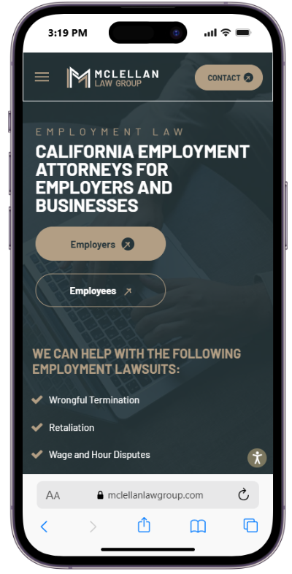
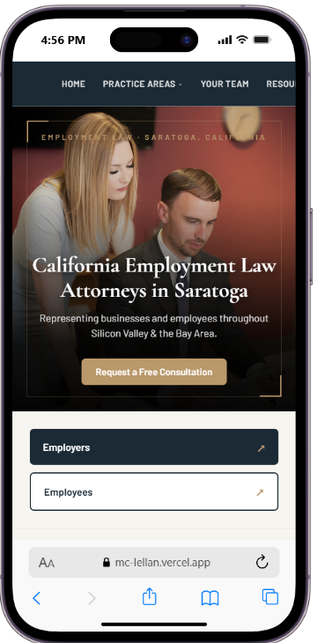

For employers

Before | After
The Employers section was a wall of text — three long dense paragraphs with no visual hierarchy and no scannable structure. On mobile, a user had to read through 150+ words covering litigation exposure, firm goals, HR policies, and service area all at once before reaching any call to action. | A single short intro line, a clean checklist of 6 services, a highlighted PAGA alert box with a clear urgency message, and a gold CTA button. The entire section is scannable in under 10 seconds on mobile.

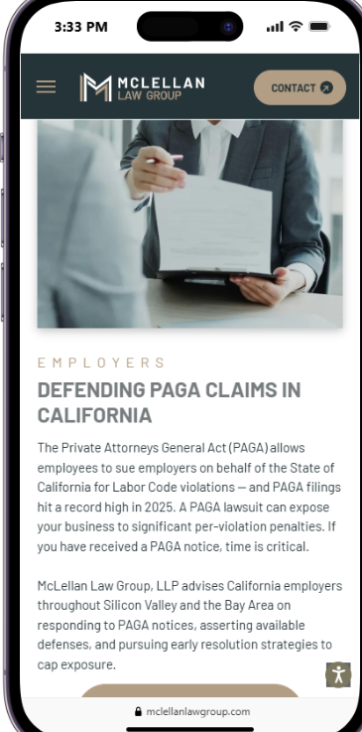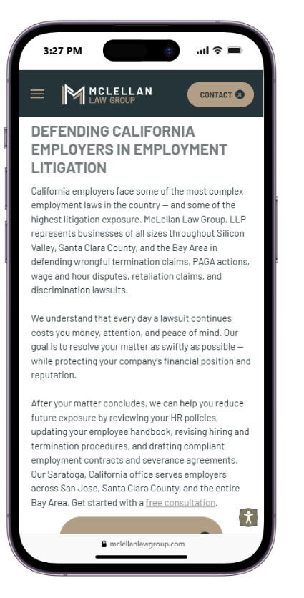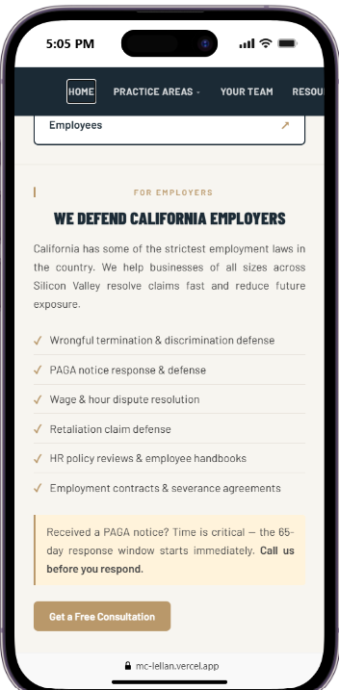

For employees

Before | After
The Employees section had a stock photo of a generic woman at a desk, a vague headline ("Protecting Employees' Rights"), and two sentences of boilerplate text with no specific services, no keywords, and no local reference. There was no checklist, no mention of Saratoga or Silicon Valley, and no clear path to action beyond a single CTA button. | Specific headline ("We Fight for Employee Rights"), one direct sentence mentioning Silicon Valley and contingency fee, 2-column grid layout with arrow markers, fitting all 6 case types in half the vertical space. Followed directly by the Employee FAQs section with clean accordion format questions visible, answers expandable on tap.

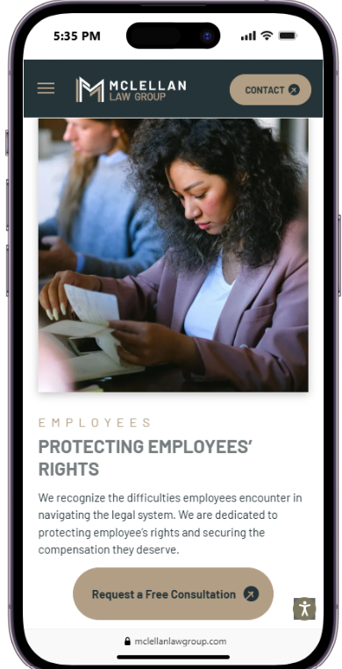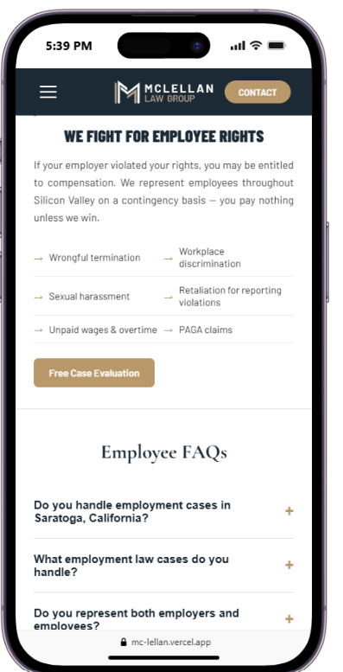

Before | After
The testimonials section displayed every review stacked vertically, one after another, with long unformatted blocks of text. On mobile, users had to scroll through several dense paragraphs before reaching any other content — making it unlikely anyone would actually read them. There were no practice area labels, no local keywords, and no visual hierarchy to guide the eye. | Each testimonial is short, punchy, and labeled with a practice area and location —Employment Law · Saratoga, Business Litigation · Saratoga reinforcing local SEO on every card. Reviews display in a swipeable carousel, so mobile users see one at a time without any extra scrolling. The format is scannable, credible, and built to convert.

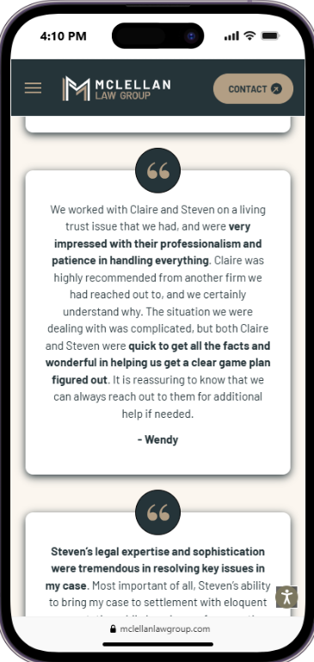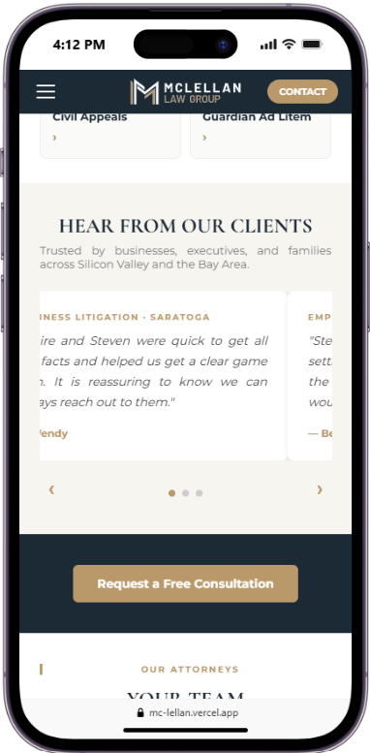

EMPLOYMENT LAW PAGE — Content Guide for Squarespace

HERO
Small label (above H1): Employment Law · Saratoga, California
H1: California Employment Law Attorneys in Saratoga
Subtitle: Representing businesses and employees throughout Silicon Valley & the Bay Area.
Button: Request a Free Consultation

AUDIENCE BUTTONS
- Employers ↗
- Employees ↗

FOR EMPLOYERS
H2: We Defend California Employers
California has some of the strictest employment laws in the country. We help businesses of all sizes across Silicon Valley resolve claims fast and reduce future exposure.
- Wrongful termination & discrimination defense
- PAGA notice response & defense
- Wage & hour dispute resolution
- Retaliation claim defense
- HR policy reviews & employee handbooks
- Employment contracts & severance agreements
Received a PAGA notice? Time is critical — the 65-day response window starts immediately. Call us before you respond.
Button: Get a Free Consultation

H3: Employer FAQs
Q: What should I do if I receive a PAGA notice in California? Contact a California employment attorney immediately. PAGA notices trigger a 65-day window during which the LWDA can decide whether to investigate. Under the 2024 PAGA reforms, employers who take early corrective action can significantly reduce penalties. Do not ignore the notice and do not retaliate against the employee who filed it.
Q: Can I be sued for wrongful termination if I have an at-will employment policy? Yes — at-will employment is a starting point, not a shield. You cannot terminate someone for a reason that violates public policy, is based on a protected characteristic under FEHA, constitutes retaliation for protected activity, or breaches an implied contract created by your handbook or offer letter. Every termination should be documented and reviewed for risk before you act.
Q: What is the difference between a PAGA claim and a class action? A class action requires court certification. A PAGA claim does not — the employee acts on behalf of the State of California with no certification requirement. PAGA penalties are calculated per employee per pay period, 75% go to the State, and they cannot be fully eliminated through arbitration agreements. The 2024 reforms introduced new opportunities to limit exposure.
Q: Do I need an employment attorney to draft a severance agreement in California? Getting it wrong is costly. For employees 40 or older, federal law requires specific timing and language. California requires a Civil Code §1542 waiver to release unknown claims. Recent state law changes restrict certain non-disparagement clauses.

FOR EMPLOYEES
H2: We Fight for Employee Rights
If your employer violated your rights, you may be entitled to compensation. We represent employees throughout Silicon Valley on a contingency basis — you pay nothing unless we win.
Wrongful termination | Workplace discrimination
Sexual harassment | Retaliation for reporting violations
Unpaid wages & overtime | PAGA claims
Button: Free Case Evaluation

CLIENT REVIEWS
H2: What Our Clients Say
Employment Law · Saratoga "Steven's ability to bring my case to settlement while keeping my focus on the bigger picture was most impressive. I would hire Steven again in a heartbeat." — Benjamin
Employment Law · Saratoga "Claire was nothing short of incredible. Always available, prompt, organized, and strategic. She won me a large settlement and I would highly recommend her." — Pete
Employment Law · Saratoga "I recommend Attorney Claire Melehani, whose efforts were immediate, determined, analytical, well considered, and constant. Throughout her personal and team efforts, Claire worked hard to build a strong, strategic, and effective case to ensure a positive resolution to an unfolding disruptive and stressful situation. Much appreciation and gratitude." — Anonymous

EMPLOYEE FAQs
H2: Employee FAQs
Q: Do you handle employment cases in Saratoga, California? Yes. McLellan Law Group is based in Saratoga, CA and represents employees and employers throughout Silicon Valley, Santa Clara County, and the Bay Area.
Q: What employment law cases do you handle? We handle wrongful termination, workplace discrimination, sexual harassment, retaliation, wage and hour violations, PAGA claims, and other employment disputes under California and federal law.
Q: Do you represent both employers and employees? Yes. We represent both employers defending against claims and employees pursuing their rights under California employment law.
Q: How much does it cost to speak with an employment attorney? We offer a free initial consultation. Many employee-side cases are handled on a contingency fee basis — you pay nothing unless we recover for you.
Q: What should I do if I was paid late? Document the late payment dates and any communications about the delay. California law requires prompt wage payments — late payments can entitle you to penalties. You may file a complaint with the California Labor Commissioner or consult an attorney to understand your remedies.
Q: What are waiting time penalties? Waiting time penalties apply when an employer willfully fails to pay final wages on time. Under California law, penalties accrue daily at the employee's regular rate of pay for up to 30 days. If your final wages were delayed after termination or resignation, you may be entitled to this additional compensation.
Q: What should I do after I've been fired? Document everything — your termination notice, communications, and the circumstances surrounding the decision. California law protects employees from wrongful termination. If you believe the firing was unlawful, consult an employment attorney promptly to preserve your rights and evaluate your options.
Q: What should I do if I'm laid off? Request written notice of your layoff and review any documents your employer asks you to sign. You may be entitled to final wages, accrued vacation pay, and WARN Act protections if the layoff involves a large workforce reduction.
Q: I received a severance agreement. Should I sign it? Do not sign without legal review. Severance agreements typically waive your right to sue — including claims you may not yet be aware of. California law and federal law impose strict requirements around timing and language, especially for employees 40 or older.
Q: What should I do if I'm demoted at work? Document the demotion and any explanation provided by your employer. If the demotion followed protected activity — such as reporting harassment or taking medical leave — it may constitute unlawful retaliation under FEHA.
Q: What should I do if I've been discriminated against at work? Document incidents with dates, witnesses, and any written communications. Report the conduct through your employer's internal complaint process if safe to do so. California's FEHA prohibits discrimination based on race, gender, age, disability, religion, and sexual orientation.

FINAL BANNER
Based in Saratoga and serving Silicon Valley, Santa Clara County, and the Bay Area.
Button: Request a Free Consultation

TECHNICAL NOTES FOR SQUARESPACE
- Page title: California Employment Law Attorneys in Saratoga | McLellan Law Group
- Meta description: McLellan Law Group represents employees and employers in employment law disputes in Saratoga, CA. Wrongful termination, harassment, PAGA, wage & hour claims — Silicon Valley.
- Image alt text: California employment law attorneys in Saratoga
- FAQs should be marked up with Squarespace's FAQ block (if available) — this enables Google rich snippets in search results.
- Canonical URL: https://mc-lellan.vercel.app/employment-law.html (update to final domain once live on Squarespace)
- {
- "@context": "https://schema.org",
- "@type": "LegalService",
- "name": "McLellan Law Group — Employment Law",
- "description": "Employment law attorneys in Saratoga, California. Representing employees and employers in wrongful termination, harassment, PAGA, wage & hour, and discrimination claims.",
- "url": "https://mc-lellan.vercel.app/employment-law.html",
- "address": {
- "@type": "PostalAddress",
- "streetAddress": "20665 4th St #202",
- "addressLocality": "Saratoga",
- "addressRegion": "CA",
- "postalCode": "95070",
- "addressCountry": "US"
- },
- "areaServed": ["Silicon Valley", "Santa Clara County", "Bay Area", "Saratoga CA"],
- "knowsAbout": ["Employment Law", "Wrongful Termination", "PAGA", "Wage and Hour", "Discrimination", "Sexual Harassment", "Retaliation"]

